„Aras SendTo“
„Aras Send To“ is a sample application how to check in files from the Windows Explorer Context Menu „Send To“.
Use Case Examples:
- For people who have to check-in many files during the day into Innovator, are now able to do so without any skills in Innovator
- Quick Check-In of files without to start Innovator
How it works:
Select one or many files in the Windows Explorer, right click the Context Menu “Send To” and select “Aras Innovator”. The Check-In Dialog will start:
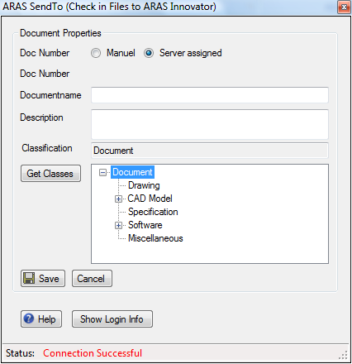
Select the appropriate Number generation method
Enter the document property values

Option: get Classes from the Item Type and let User make a class selection
Click Save for Check In

Configuration:
If you check-in a file for the first time, you have to set the connection and login Information.
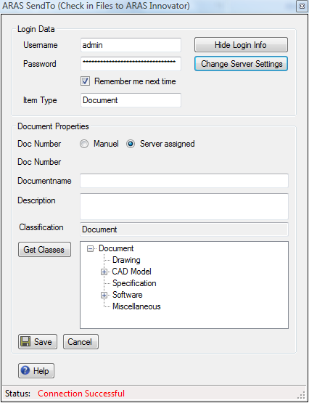
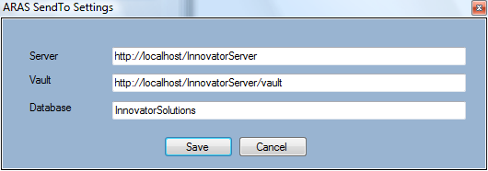
Both Information, the connection settings and the login parameters get saved in your cookies folder. Next time you check-in a file, you get the form without the settings section.

Remarks:

The number of files you can check-in is limited to the length of the parameter string windows can handle and send to the application. This depends on the Windows version you are using.

It would probably look better if we put a link in the SendTo Folder instead of the .exe (user would not see the .exe extension). The problem is, that links can receive less parameters then the .exe (at least under Vista). There is certainly a way to develop a dedicated “Send To Target” and get around this issue. This would require some Registry entries I decided not to do for this sample.

The IOM.dll is included in the .exe. This is done with Microsoft’s ILMerge Program. The required Program and a .bat example is saved in the debug directory in the Visual Studio Project.

2.10.08/M.Allemann

